**How to make lava cake**

**Preparation and sifting dry ingredients**

[](https://www.mediavine.com/)

1. First grease 3 medium ramekins with oil very well. Keep aside. Meanwhile preheat oven to 200 degrees celsius/395 degrees fahrenheit for 15 to 20 minutes. Heat only the bottom element of the oven. In microwave oven, use the convection mode and preheat for 15 minutes at 180 degree celsius.

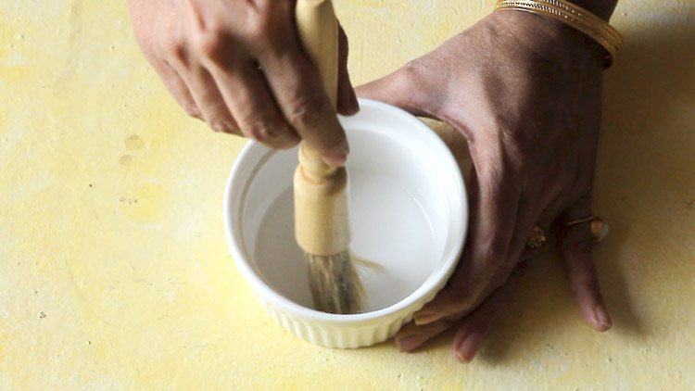

2. Take a bowl and place a sieve on it. Add ½ cup whole wheat flour (60 grams).

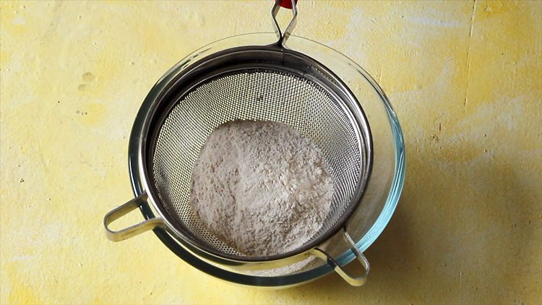

[](https://www.mediavine.com/)

3. Then add 3 tablespoons cocoa powder and a pinch of salt.

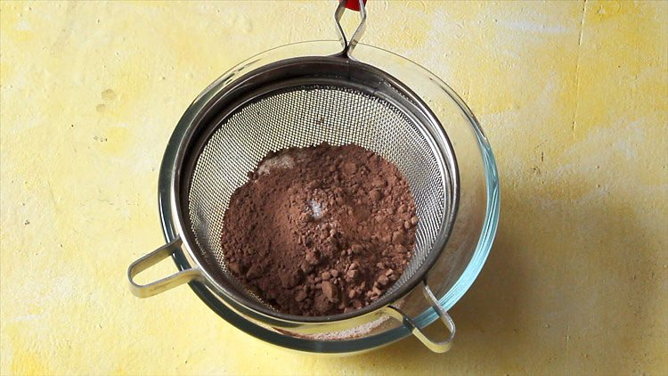

4. Next add ¼ teaspoon baking soda. Since baking soda is the only leavening ingredient used in the recipe, do make sure that its fresh and active. To check the freshness of baking soda, dissolve a bit of baking soda in a solution of vinegar+water. It should fizz and bubble immediately. If not, then the baking soda is not fresh and active.

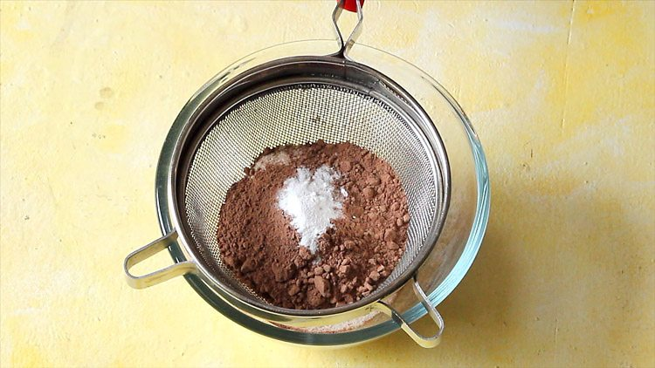

[](https://www.mediavine.com/)

5. Sift the dry ingredients directly in the bowl.

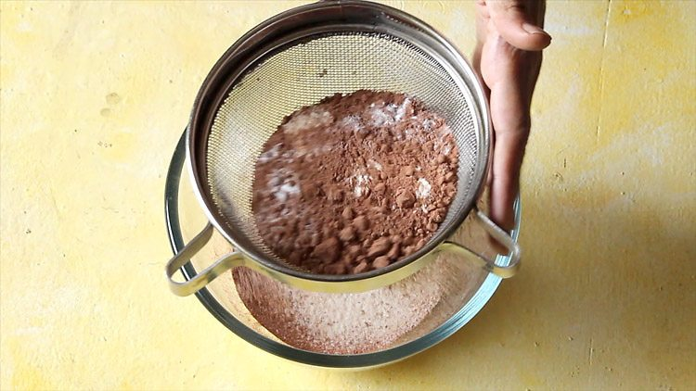

6. keep the sifted dry ingredients aside.

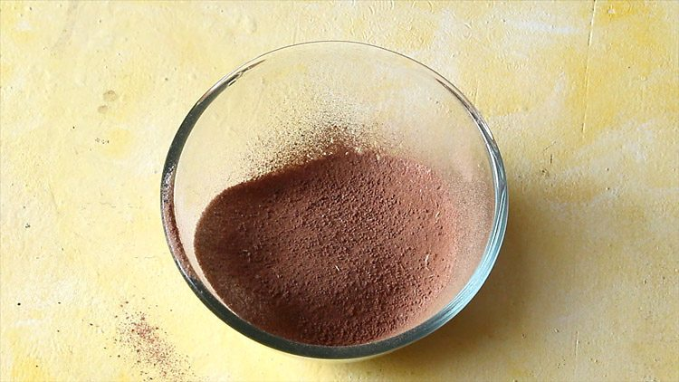

**Preparing wet ingredients solution for choco lava cake**

7. In another bowl, take ⅓ cup sugar.

[](https://www.mediavine.com/)

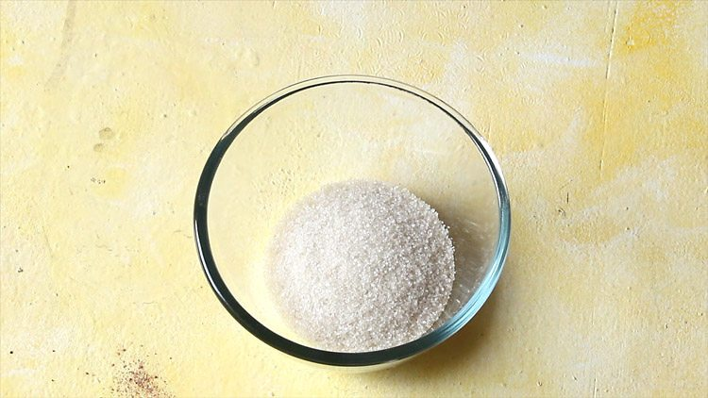

8. Add ½ cup cold water. Do use cold water only as it gives the best texture in the cake.

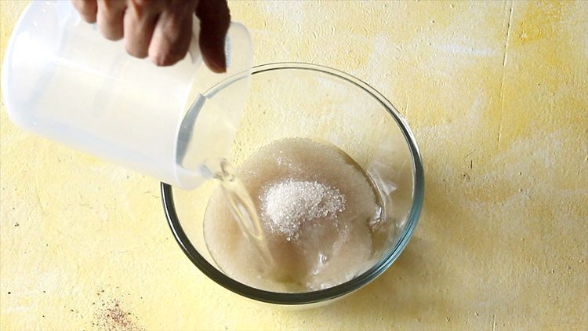

9. Using a spoon or a wired whisk mix very well till all the sugar is dissolved.

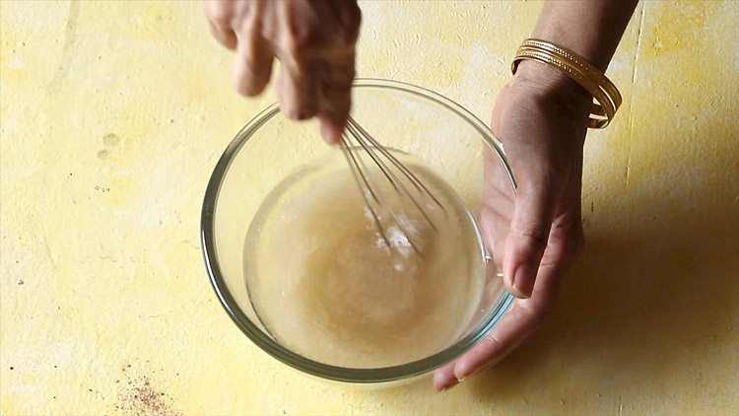

[](https://www.mediavine.com/)

10. Now add 2 tablespoons oil. You can use sunflower oil or olive oil.

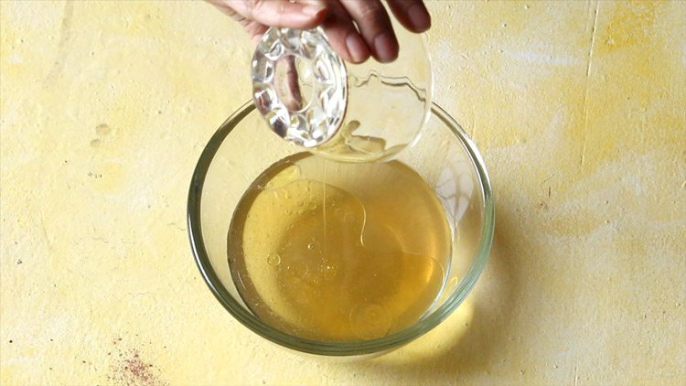

11. Using a wired whisk mix the oil very well with the sugar+water solution.

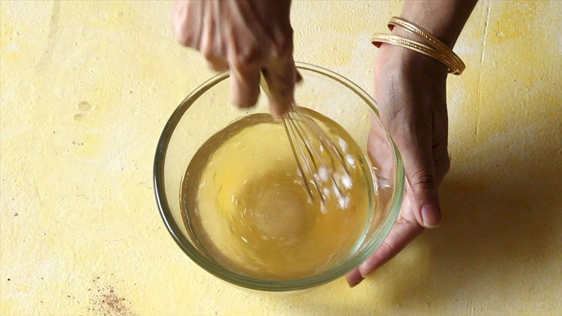

[](https://www.mediavine.com/)

12. Now add ½ teaspoon vanilla extract . If using vanilla essence, then add ¼ teaspoon of it.

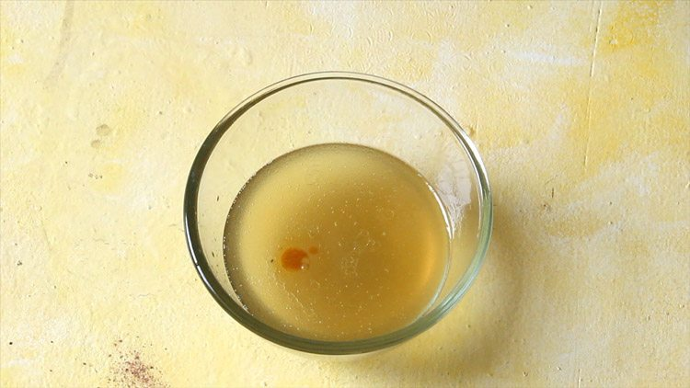

13. Add ½ tbsp lemon juice. Instead of lemon juice, you can also use white vinegar or apple cider vinegar.

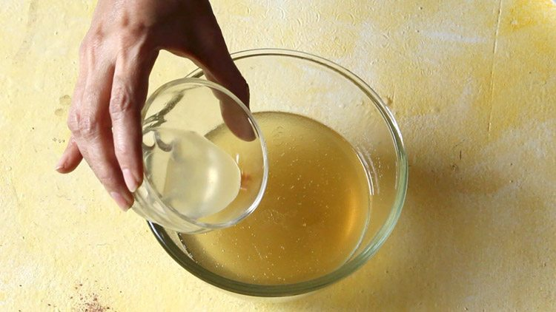

[](https://www.mediavine.com/)

14. Again mix very well.

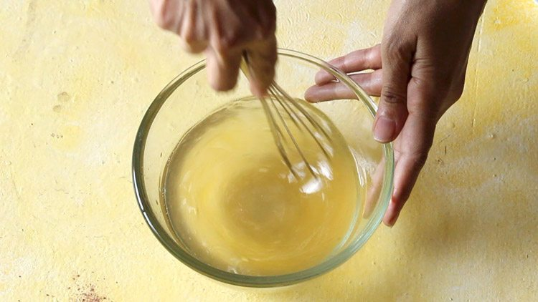

**Making chocolate lava cake batter**

15. Now add the wet ingredients to the sifted dry ingredients.

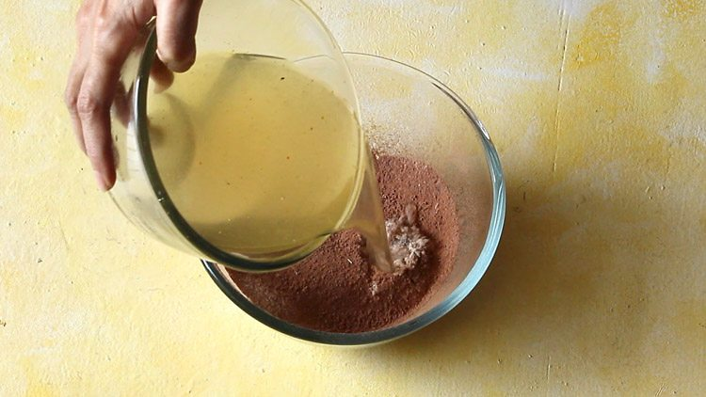

[](https://www.mediavine.com/)

16. With a wired whisk, stir and mix well. Do not over do the mixing.

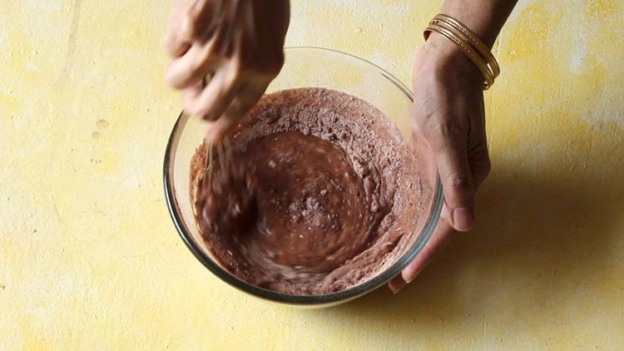

17. Prepare a smooth batter. The batter for this lava cake recipe has medium-thin consistency.

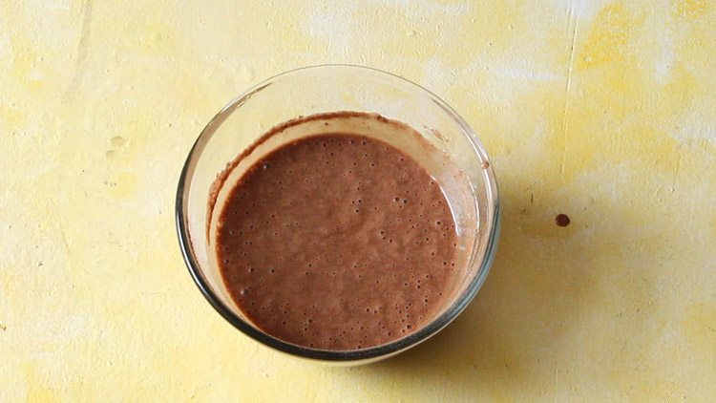

[](https://www.mediavine.com/)

18. Pour the lava cake batter in the greased ramekins till ⅔ of their volume.

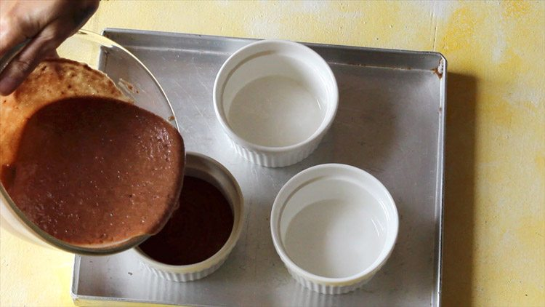

19. Place chocolate squares in the batter. I have used 70% cocoa bitter sweet chocolate. Please use good quality couverture or compound chocolate which are meant for baking to get the lava effect. Use chocolates which are firm and hard. Avoid using chocolate which are soft, semi-soft or fluid. Please do not use ready to eat chocolate like dairy milk etc.

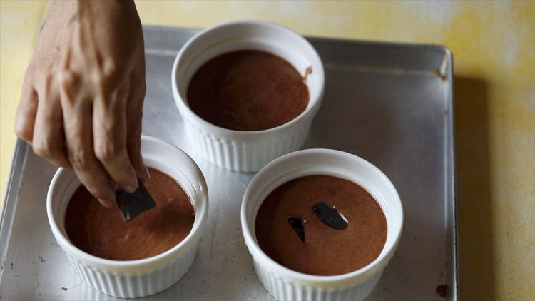

[](https://www.mediavine.com/)

20. With a spoon or wired whisk lightly press them so that they get immersed in the batter. If you have a chocolate slab, then chop the chocolate before you prepare the batter. The batter should immediately go in the oven as soon as possible.

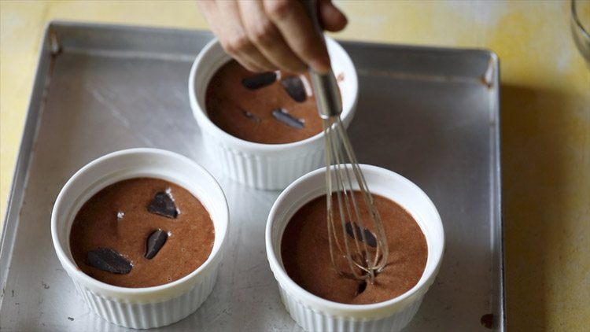

**Baking chocolate lava cake**

21. Place the ramekins in the center rack of the oven. Bake at 200 degrees celsius for 30 to 40 minutes. In my oven the baking took about 35 minutes. During the last 10 minutes do keep a check. also open the oven door only after ¾th of the cakes are baked. If you open early or open many times, the lava cakes can fall flat. I generally bakes lava cakes well as I do not want my folks to eat any uncooked batter.

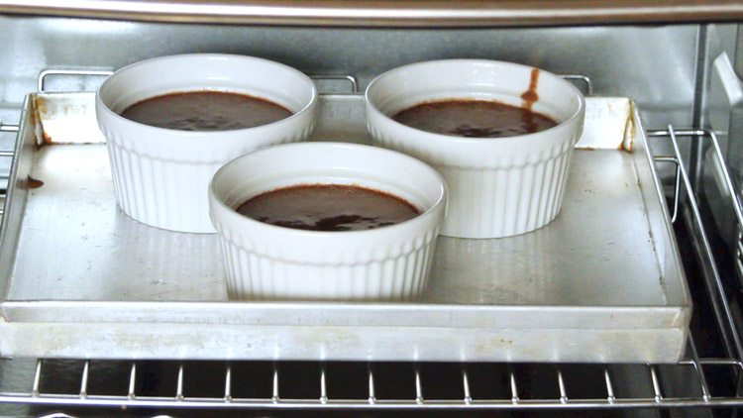

[](https://www.mediavine.com/)

22. Baking time varies with various oven makes and models, so it can take less than 30 mins or more than 35 minutes. Check with a toothpick on the sides of the cake and it should come out clean.

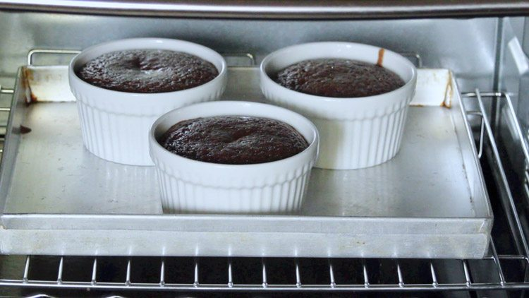

23. Let the chocolate lava cakes cool for two to three minutes. Then with a butter knife gently loosen the edges from the top. The cake is so light and soft, you do not need to use the butter knife way to the base of the ramekins.

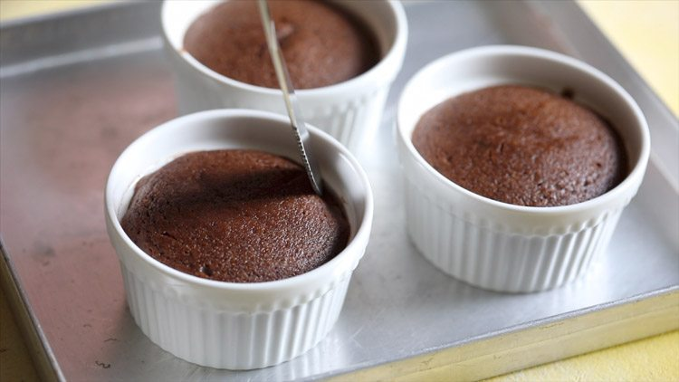

[](https://www.mediavine.com/)

24. Invert the ramekin on a serving plate. Gently tap the bottom of the ramekin. The ramekins will be hot, so be careful when picking and tapping them.

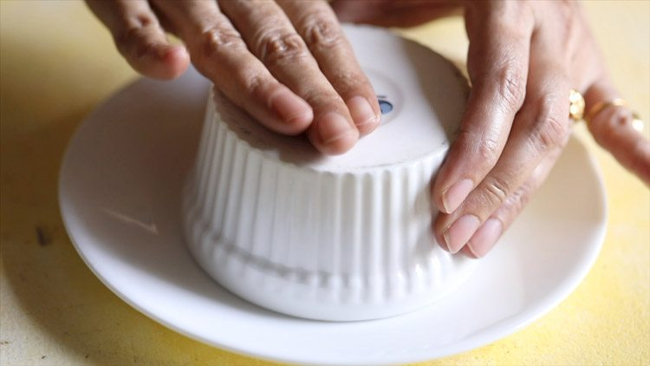

25. Remove the ramekin gently and the cake gets unmolded easily. Sift some cocoa powder or powdered sugar on top through a sieve. **You can also serve molten lava cake with** ice cream like vanila ice cream or chocolate ice cream or mango ice cream or some berries or fruits by the side.

**Choco lava cakes have to be served hot or warm**. once they cool, the molten chocolate solidifies. But even at room temperature these lava cakes taste good.

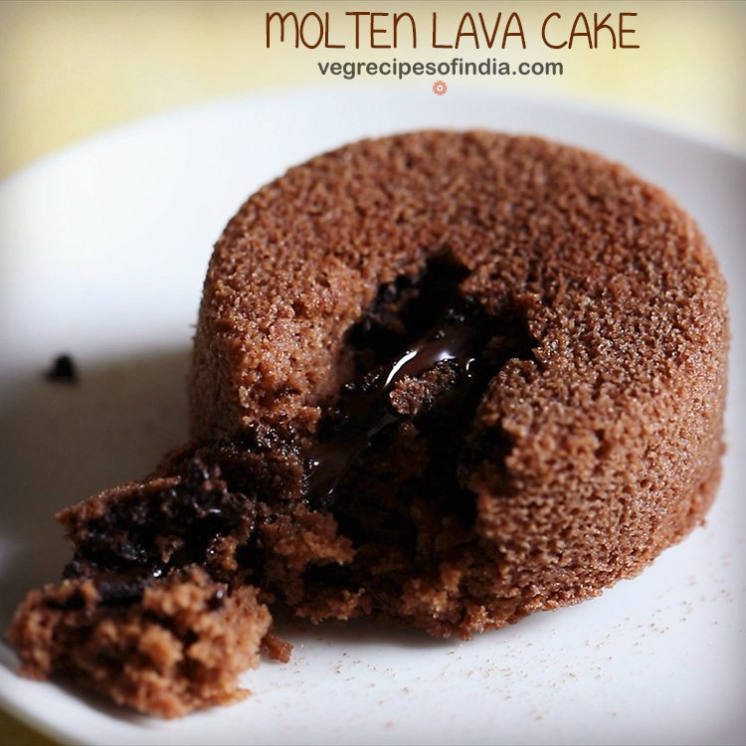

It is ready to eat hot…